A monoclonal antibody to Stem Cell Factor (SCF) attenuates pulmonary disease remodeling responses

Nicholas W. Lukacs1,3, Steven L. Kunkel1,3, Sumanta Mukherjee1, David Habiel2, Andrew Rasky1, Martin Phillips3, and Cory M. Hogaboam1,2,3.
1University of Michigan Medical School, Department of Pathology, Ann Arbor, MI. 2Cedar Sinai Hospital, Los Angeles, CA. 3Opsidio, LLC, Philadelphia, PA.

Stem cell factor (SCF) and its receptor c-Kit have been implicated in tissue remodeling and fibrosis. Using
Ingenuity Software to analyze public IPF patient microarray databases it was demonstrated that SCF is highly A
upregulated in IPF patients compared to normal and further upregulated in exacerbated patients compared to
stable IPF. The Ingenuity analysis also demonstrated the linkage of SCF to multiple pro-fibrotic pathways that have previously been shown to be important in IPF progression. Our studies have previously demonstrated that by blocking SCF the fibrotic responses in bleomycin and chronic allergic asthma models, the pathophysiologic aspects of disease are mitigated. We have recently made a mouse anti-human SCF monoclonal antibody that cross-reacts to mouse SCF and utilized it in three independent pulmonary fibrotic disease models to determine its suitability as a human therapeutic. In the first model, fibrosis was induced by intratracheal instillation of bleomycin (BLM), which causes increased SCF levels in plasma, bronchoalveolar lavage fluid (BALF) and lung tissue. The intratracheal administration of the monoclonal anti-SCF antibody (OpSCF) in a therapeutic modality on days 8 and 12 after bleomycin treatment significantly reduced the histologic pathology and collagen staining. In addition, the treatment of animals with OpSCF significantly reduced the pulmonary mRNA expression of collagen genes (1 & 3) and Th2 cytokines. In a second model of chronic lung fibrosis using fibroblasts from IPF patients injected into SCID mice, OpSCF was administered intranasally using a therapeutic regimen beginning on day 35 of the pulmonary fibrotic model once every 3 days until termination of the experiment on day 65. The results demonstrated a reduction in the developing fibrotic response by both histologic examination and by hydroxyproline analysis. Finally, using a model of chronic cockroach allergen-induced asthma that results in remodeling of the airways, the administration of OpSCF into the airways during the terminal phases of the disease model alleviated the airway disease, including airway hyperreactivity, peribronchial inflammation and eosinophilia, mucus, and airway thickening/ remodeling as well as key pathologic cytokines. Together, these data demonstrate that by blocking SCF in a therapeutic manner during the development and within established disease a significant reduction in lung remodeling disease can be achieved. Thus, OpSCF provides an avenue to alter the development and progression of chronic remodeling pulmonary diseases and provides important pre-clinical data to demonstrate
B

B C

Hydroxyproline
10 50
Fold Change over Naive
normalized to GAPDH (2^-ddCt)

8 40
ug/mg protein
*
6 30

20
4

10
2
0
0

D

IL13

Col-1A1
Fold Change normalized to GAPDH (2^-ddCt)
10 * p=0.056
8

6

4

2

0

Col-3A1
5
* *
4

3

2

1

0

efficacy of targeting this novel target.
Bleo control
Bleo + OpSCF
Fold Change normalized to GAPDH (2^-ddCt)
Figure 2- Treatment of mice on Day 8 and 12 with an anti-SCF monoclonal Ab (OpSCF) by airway instillation attenuates the development of bleomycin-induced pulmonary fibrosis. The changes include alteration of Histological changes (A), measurement of hydroxyproline (B), pro-fibrotic cytokines (C), and extra-cellular matrix protein mRNA expression (D).

SCF is a primary cytokine involved in hematopoietic cell development of multiple lineages, as well as mast cell differentiation and activation(1). SCF dimerizes and binds to a cell-surface receptor, c-Kit, which is a member of the receptor tyrosine kinase family. SCF occurs in both “membrane” and “soluble” forms. Both are splice variants of the same transcript, and initially expressed as transmembrane proteins. Only the soluble form has an enzyme cleavable domain, which allows the extracellular portion of “soluble” SCF to be released from the surface of the cell. Some studies have suggested that it is primarily a monomer in circulation, which is not sufficient for c-kit activation. In the mouse, SCF is encoded by the Steel (Sl) locus on chromosome 10, and c- Kit is encoded by the White-spotting (W) locus on chromosome 5. In studies using COS cells transfected with full-length SCF that includes the cleavable domain, 95% of the expressed SCF was cleaved from the surface and available in a soluble form. However, the interaction of c-Kit with membrane associated SCF induces a stronger and more prolonged tyrosine kinase activation signal than the cleaved soluble extracellular domain. Importantly, studies have also demonstrated that the “membrane” (uncleavable) form of SCF is most important for hematopoiesis, whereas the “soluble” (cleavable) form is more closely associated with inflammation. The mechanism for cleavage is unknown, but several inflammation-associated proteases appear to be able to mediate the event.
The SCF receptor, c-Kit, is found on hematopoietic derived cells, melanocytes, germ cells, eosinophils, some lymphocytes, and highly expressed on mast cells with little or no expression on basophils. SCF protein has been identified in bone marrow stromal cells, fetal liver stromal cells, epithelial cells, smooth muscle cells, fibroblasts, and upregulated on myofibroblasts.
A B
p = 0.033
10
p = 0.036

8
Hydroxyproline
(µg/mg protein)

6

4

2

0

ANOVA - 0.03

The ability of SCF to directly activate effector leukocytes, including mast cells and eosinophils, may be central to its involvement in inflammatory and pro-fibrotic responses. Data have accumulated for the importance of SCF-induced activation for mast cells, not only related to allergic responses, but also during fibrotic responses. Several studies have now demonstrated that inhibition of SCF clearly attenuates the severity of the allergen- induced as well as fibrotic responses in murine models of pulmonary disease. In the present study, the data offer additional convincing data that blocking SCF during the fibrotic phases of lung remodeling responses using a monoclonal antibody has a profound effect on the progression and severity of interstitial and airway remodeling responses. The inhibitory effect in these well established models gives additional evidence for pursuing blocking of SCF as a therapeutic strategy.
Figure 1- Ingenuity Software analysis of Lung Microarray demonstrating
upregulation of SCF (KITLG) in IPF vs. normal lung (A) and in exacerbated IPF disease compared to stable IPF disease patient lung (B) with interactive relationships to other upregulated genes.

A
Figure 3- OpSCF treatment attenuates the severity of the SCID-Hu model of Pulmonary Fibrosis. Fibroblasts grown from patient biopsies with advanced IPF
were injected IV into SCID mice. Animals developed progressive interstitial remodeling over a 65 day period. Beginning on day 35 animals were treated with 3 mg/kg control or OpSCF monoclonal Ab every 3rd day until harvest. OpSCF treated animals demonstrated both reduced histologic remodeling (A) and lung hydroxyproline levels (B).

Generation of OpSCF anti-SCF monoclonal antibody- An immunogenic peptide to human SCF was identified with a contract research organization (GenScript, Inc.) and multiple hybridomas generated by standard methodology using mice. Selection of a high affinity mouse/human cross-reactive antibody was determined by direct ELISA, by Western blot and verified by BiaCore analysis. Additional testing demonstrate efficacy using in vitro cell assays.

Bleomycin Model- C57/Bl6 mice were injected with Bleomycin (Blenoxane, Mead Johnson, Princeton, NJ) at a dose of
2.5 U/kg or with PBS (2). Animals were treated with a mouse anti-SCF (OpSCF) or control monoclonal antibody at a dose of 3 mg/kg given into the airway on days 8 and 12 post-bleomycin instillation during the remodeling phase. Animals were harvested on day 16 of the response and reported parameters assessed.

SCID-Hu model of pulmonary fibrosis- Female C.B.-17-scid-beige mice received single-cell suspensions of fibroblasts grown from tissue of patients diagnosed with IPF (ERS/ATS criteria) or from normal lung tissue (2 X 106) via tail vein injection (3). On day 35 post cell instillation animals were treated with with an anti-SCF (OpSCF) or control
rd
Fold Increase over Naive

Allergen
B C
8
Change in airway resistance
(cmH2O/ml/sec)

6
P=0.038

4

20000

10000

250
200
150
100 *
• Inhibition of SCF using an airway administered monoclonal antibody given in a therapeutic modality attenuates both interstitial and airway remodeling disease.

• Treatment of animals with OpSCF monoclonal antibody significantly reduces numerous mediators associated with chronic remodeling diseases, including IL-13.

• Blockade of SCF leads to inhibition of pathogenic expression of extracellular proteins during interstitial fibrosis and mucus
* gene expression during chronic allergen exposure.

*** SCF appears to be a critical upstream target for therapeutic treatment of chronic pulmonary remodeling diseases.

monoclonal antibody at a dose of 3 mg/kg given into the airway every 3
post-fibroblast instillation and parameters assessed.
day. The animals were harvested on day 65
2
50 *
**
0
CRA + CIg

CRA + OPSCF
-
CRA + CIg
CRA + OPSCF
-
CRA + CIg
CRA + OPSCF

1. Ashman, LK. The biology of Stem Cell Factor and its receptor C-­‐kit. Int. J Biochem Cell Biol. 10:1037-­‐51.

Chronic allergen-induced airway model of Asthma- Balb/c mice (Jackson Lab, Bar Harbor, ME) were immunized with
-
clinical grade cockroach allergen (<20 ng/ml LPS) in IFA by IP injection (4). On day 14 and every 4 days thereafter 0
until day 34 animals were given an intra-airway instillation of allergen (10 ug/treatment). On day 30 and 34, the final two allergen challenges, animals were treated with treated with OpSCF or control monoclonal antibody at a dose of 3
mg/kg given into the airway. The animals were harvested on day 35 and assessed for the reported parameters.

IL-13 IL-17 Muc5ac gob5
CRA + CIg
CRA + OPSCF

2. Dolgachev V, Wu Z, Liu T, Nakashima T, Wu Z, Ullenbruch M, Lukacs NW, and Phan SH. 2013. EssenUal role of Stem Cell Factor/c-­‐kit signaling pathway in Bleomycin-­‐induced
pulmonary ﬁbrosis. J. Pathol. 230:205-­‐14.

3. LA Murray, H. Zhang, SR Oak, AL Coelho, A Herath, KR Flaherty, J Lee, M Bell, DA Knight, FJ MarUnez, MA Sleeman, EL Herzog, and CM Hogaboam. 2014. TargeUng

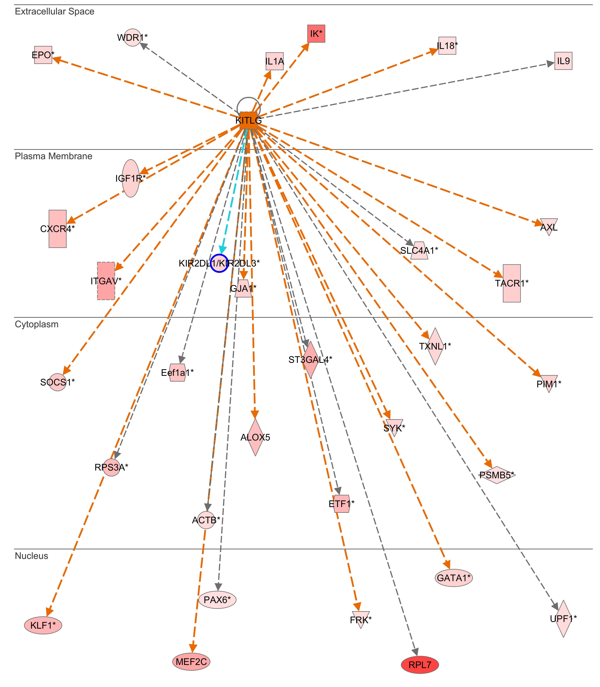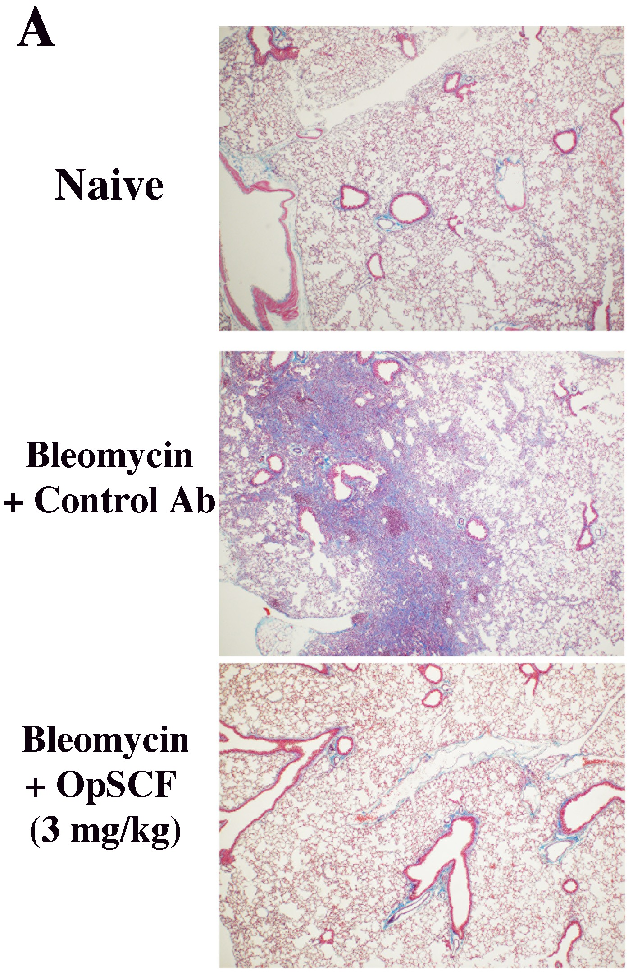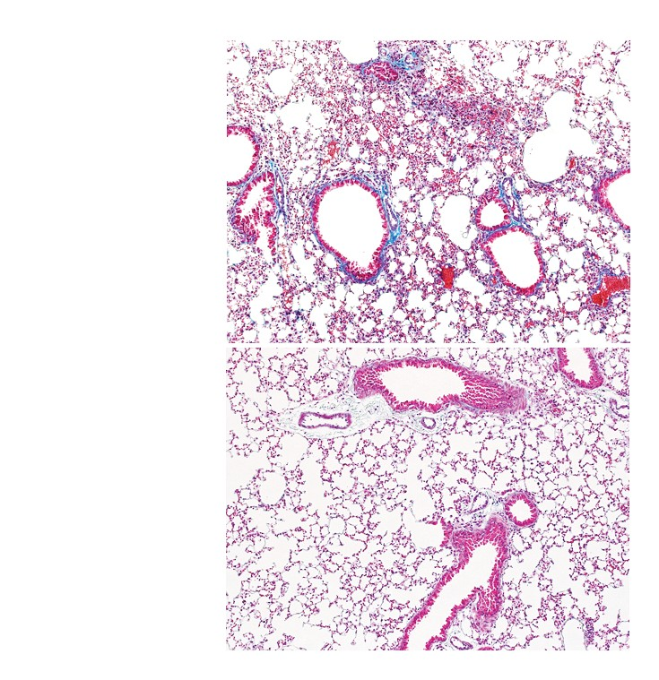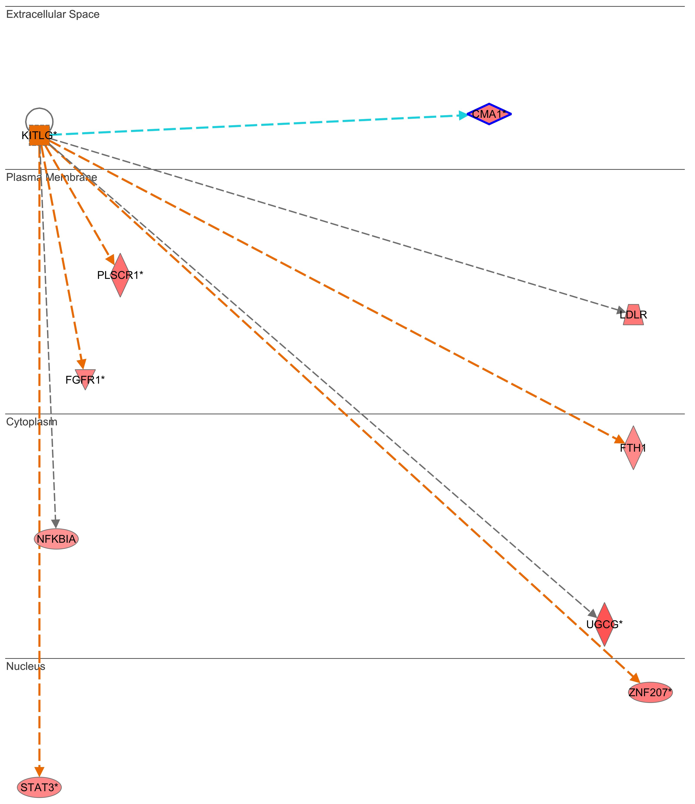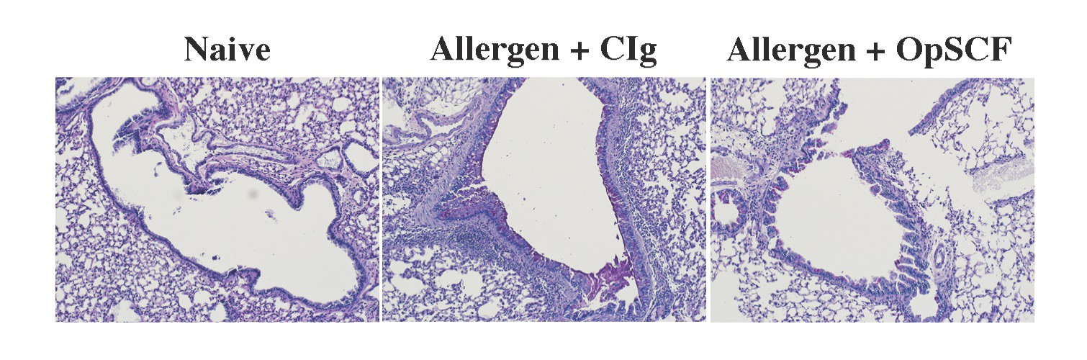Figure 4- Therapeutic inhibition of SCF during chronic allergen model of asthma with OpSCF attenuates peribronchial inflammation/remodeling (A), Airway hyperreactivity (B), and reduces key cytokine and mucus gene mRNA levels (C).
Interleukin-­‐13 with Tralokinumab a]enuates lung ﬁbrosis and epithelial damage in a humanized SCID Idiopathic pulmonary ﬁbrosis model. Am. J. Resp. Cell Mol. Biol. 5:985-­‐994.

4. A.A. Berlin, C.M. Hogaboam, and N.W. Lukacs. In hibiUon of SCF a]enuates peribronchial remodeling in chronic cockroach allergen-­‐indeuced asthma. 2006. Lab Invest. 86(6):
557-­‐65.

